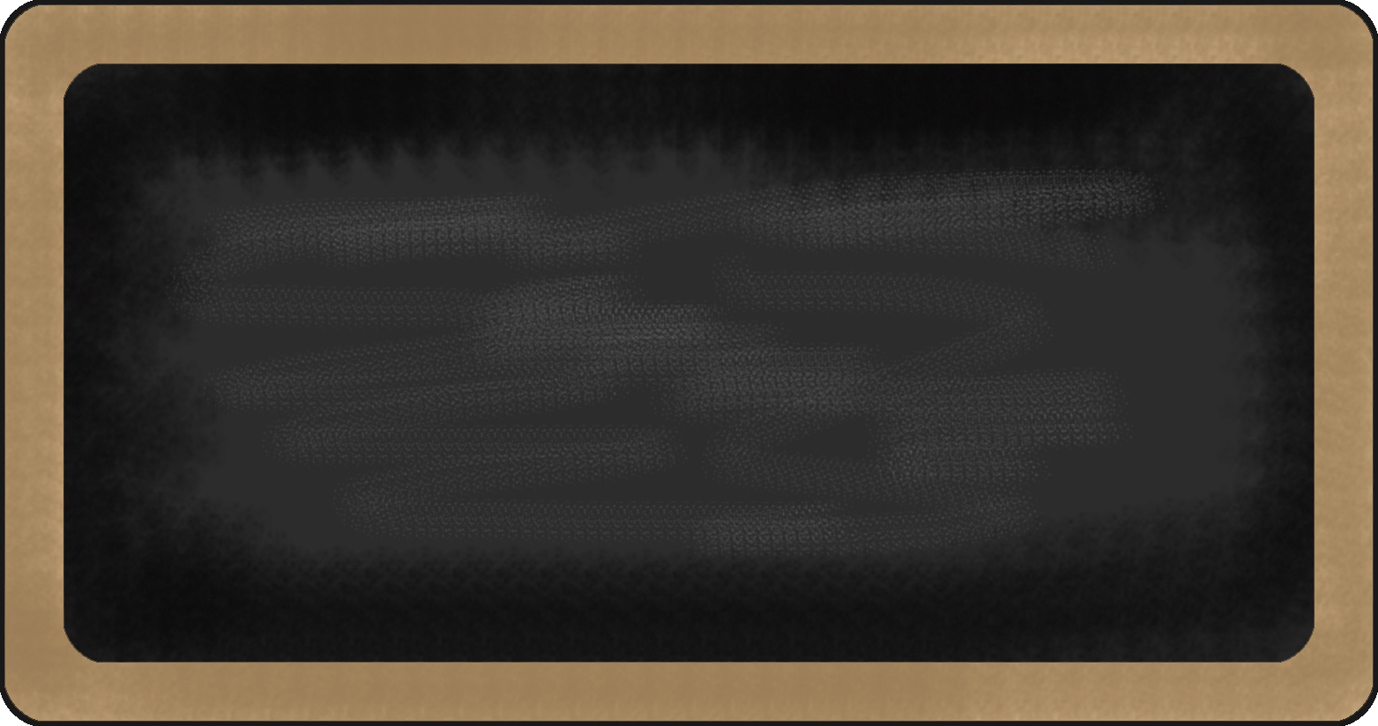

Kindergarten News

Sight Words
a, like

Upcoming events

October 26th – Halloween Howl (6:00 -7:30 pm)
October 31st – Classroom Halloween celebration (See attached sheet)
November 5th – Picture Retake Day





Notes from the teacher:
Please sign up for FreshGrade! It is a wonderful way to connect to your child’s learning at school.
The cooler weather is here. Please ensure that your child is dressed for the season.
Our breakfast program is going well! Enjoy it when you arrive (if you’re hungry).
The breakfast program closes at 8:00 am.
Students are working on not blurting (speaking out of turn, interrupting). Keep up the hard work!
School fees and supplies are due. We need your support! Thank you.
If you have any questions or concerns please feel free to contact me at rolly.sidik@nbed.nb.ca, or call the school.




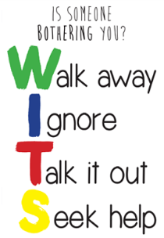


What we are learning this week:

Reading | Writing |   Math | You and Your World
- New Letters: m, d  - Sight Words: like, a  - Strategy: Eagle Eye – Look at the picture. Think “What is in the picture that starts with the beginning letter?”  - Review letters: s, a, t, i, p, n, c/k, e, h and r  - Review sight words: is, to, I, me | - Practice writing proper letter formations for: h, r, p, n, t, i, s, a, c/k, e  - Practice reading, writing and spelling sight words: the, is, me, I, to  - Practice writing their names | - Subitizing ( Recognize a familiar arrangements of objects at a glance)  - Relate a numeral to its quantity 0 to 5  - Say the number sequence 0 to 5  - Identify, create and reproduce patterns | - W.I.T.S. Strategy (Walk Away, Ignore, Talk it out, Seek help)  - Habit 1: Be proactive.

